Instructions for Setting-Up the Project

1. **The Software**
   1. Android development is based on the Eclipse IDE and the special addition of the Android Software Development Kit (SDK), sometimes known as Android Development Tools (ADT).
   2. Android offers a bundle with the basic Eclipse development environment pre-loaded with the Android SDK.
      1. Download and install this bundle to get the development environment
      2. http://developer.android.com/sdk/index.html
   3. Download and unzip the SliderPuzzle folder
2. **Importing a Project**
   1. With the environment installed, click on the ADT icon  
      (green circle with black brackets)
   2. Select a workspace:
      1. Any location on your computer where you would like to store the files for your project
      2. 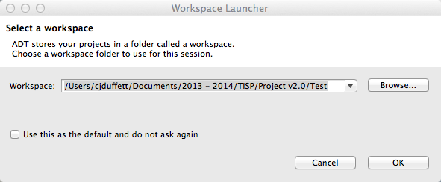The ADT will copy a folder to this location with all of the code and resources for your Android projects
   3. 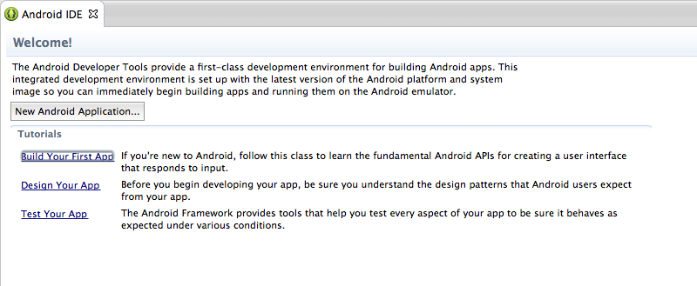The ADT will finish loading and will present you with a menu:
   4. Skip the menu and go to:
      1. File 🡪 Import
   5. Select:
      1. Android 🡪 Existing Android Code into Workspace
      2. 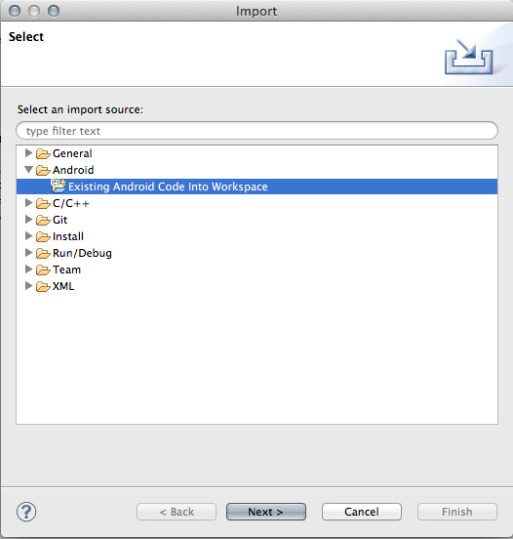Click next
   6. Select the Slider Puzzle Project
      1. The top of this menu will prompt you for a “Root Directory”
      2. Browse for the SliderPuzzle folder that you downloaded to your computer
      3. 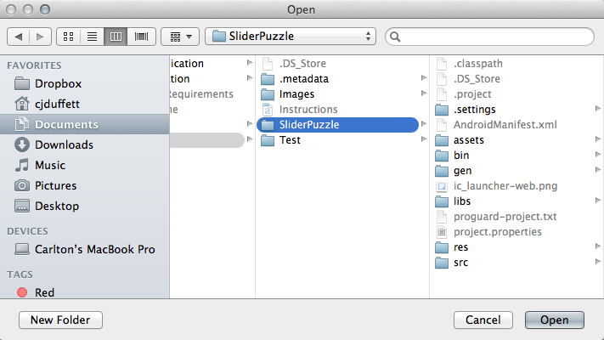Select the **entire folder**
   7. 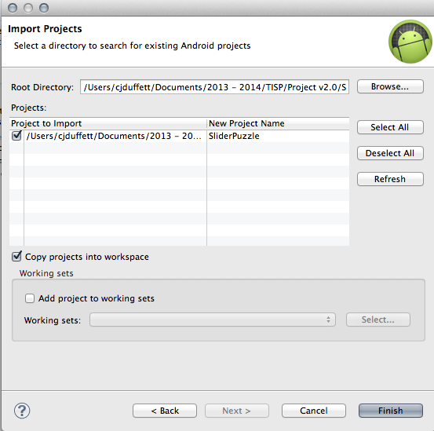**IMPORTANT:** make sure that you select the “Copy projects into workspace”
   8. 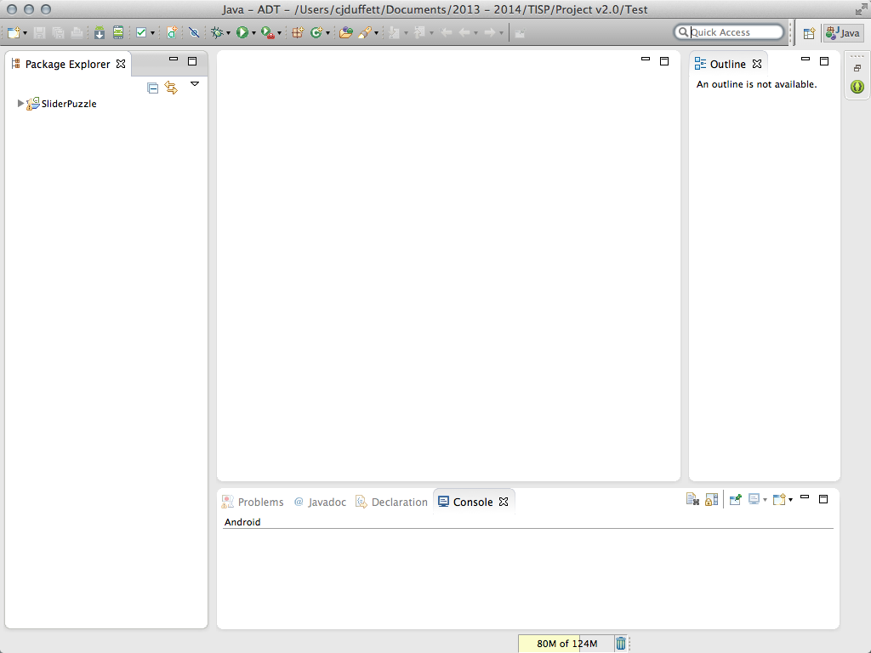The Android development environment will open with a blank project. You can do the following:

Minimize the “Outline” and “Console” windows

* 1. 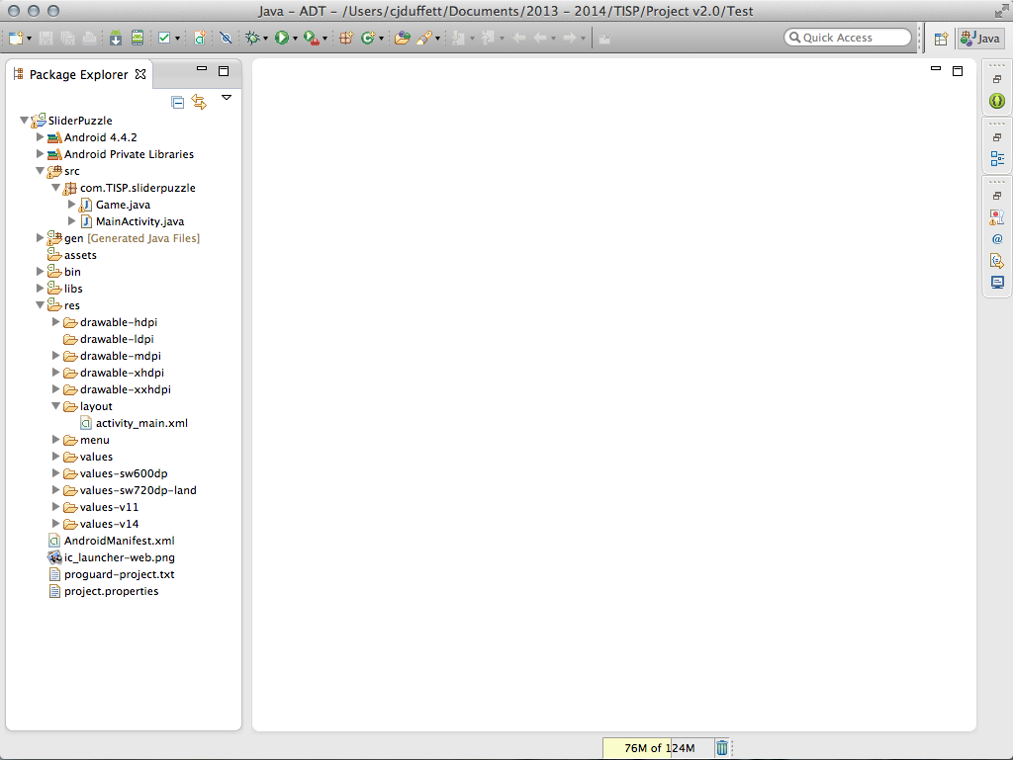Put the tabs in the order we will be working with them for this project, then minimize the “Package Explorer Window”. The order is:

Expand the SliderPuzzle Folder and open:

1. src 🡪 com.TISP.sliderpuzzle
   1. Game.java
   2. MainActivity.java
2. res 🡪 layout
   1. activity_main.xml
      1. activity_main.xml
      2. 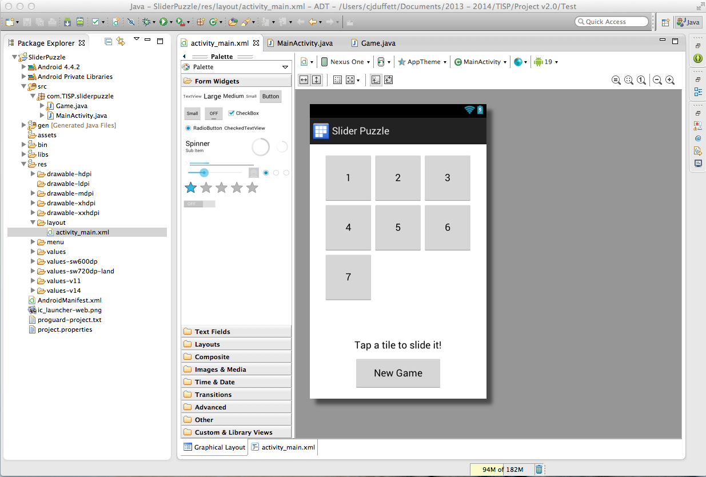MainActivity.java
      3. Game.java

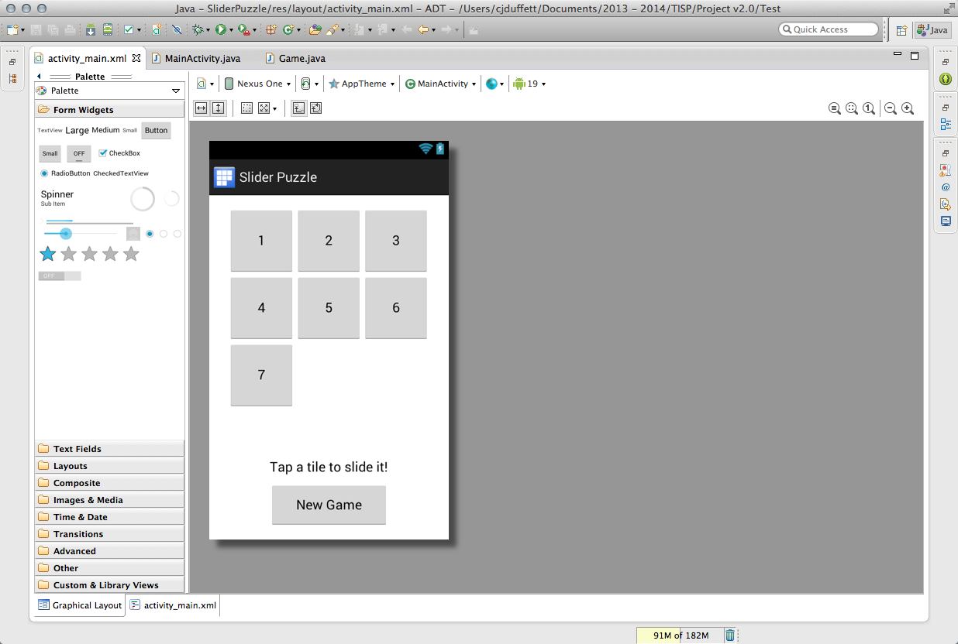Before you continue, the development environment should look like this:

This is how the project will be configured when it is presented to students.

1. **Configuring a Device for Testing**
   1. To make testing easier during the project, the testing device must be preconfigured. On your Android device, do the following:  
      1. Enable USB Debugging  
         Settings 🡪 {} Developer Options 🡪 USB Debugging
      2. Configure the connection type  
         Settings 🡪 PC connection 🡪 Default connection type 🡪 Charge Only
      3. Plug your device into the USB port of your computer
   2. Select one of the Java files, either MainActivity.java or Game.java
      1. For whatever reason, Android apps can only be run/debugged if you current file is a .java file.
      2. If your current file is a .xml file, nothing will happen when you click “run”
   3. Press the “run” button in the menu:
   4. You will initially be presented with a “Run As” menu.
      1. Select “Android Application”
      2. 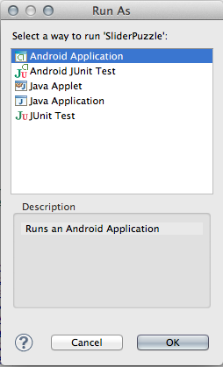Click OK
   5. Android will then ask you to choose a device to run your app on.
      1. Your personal device should appear in “Choose a running device” menu
      2. 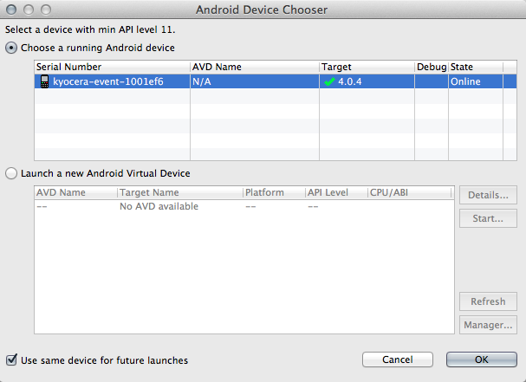Select “Use same device for future launches” to save these options for next time
   6. After a moment, a popup should appear on your screen that says:  
        
      “Unfortunately, Slider Puzzle has stopped.”  
        
      This is due to the initial configuration of the project and is normal. If you receive this message, you can assume that everything is running as normal and you are now ready to begin the project.